**DAILY ONLINE ACTIVITIES SUMMARY**

|  |  |  |  |  |  |  |  |  |
| --- | --- | --- | --- | --- | --- | --- | --- | --- |
| **Date:** | **07-06-2020** | | | | | **Name:** | **Nachiketh S Bhat** | |
| **Sem & Sec** | **6th  Sem ‘B’ Sec** | | | | | **USN:** | **4AL17CS119** | |
| **Online Test Summary** | | | | | | | | |
| **Subject** | | **SSCD** | | | | | | |
| **Max. Marks** | | **30** | | **Score** | | | **21** | |
| **Certification Course Summary** | | | | | | | | |
| **Course** | E-Box (no class) [Start Course](https://courses.cognitiveclass.ai/courses/course-v1:developerWorks+BC0101EN+v1/jump_to/block-v1:developerWorks+BC0101EN+v1+type@course+block@course) | | | | | | | |
| **Certificate Provider** | | | **E-box** | | **Duration** | | | **-** |
| **Coding Challenges** | | | | | | | | |
| **Problem Statement:**   1. java Program to print smallest and biggest possible palindrome word in a given string 2. Python program the first and last 5 elements   **# P-1**  **Program to Check whether a number can be represented as difference of two squares**  **# P-2**  **C Program to Generate All the Set Partitions of n Numbers Beginning from 1 and so on**  **# P-3**  **Java program to delete a node from the middle of the singly linked list**  **# P-4**  **Python program to find whether a string is a palindrome or not** | | | | | | | | |
| **Status: done** | | | | | | | | |
| **Uploaded the report in Github** | | | | | **yes** | | | |
| **If yes Repository name** | | | | | <https://github.com/nachi0106/Daily-Activity/tree/master/Online-coding%20report/07-06-20> | | | |
| **Uploaded the report in slack** | | | | | **yes** | | | |

**Online Test Details:**

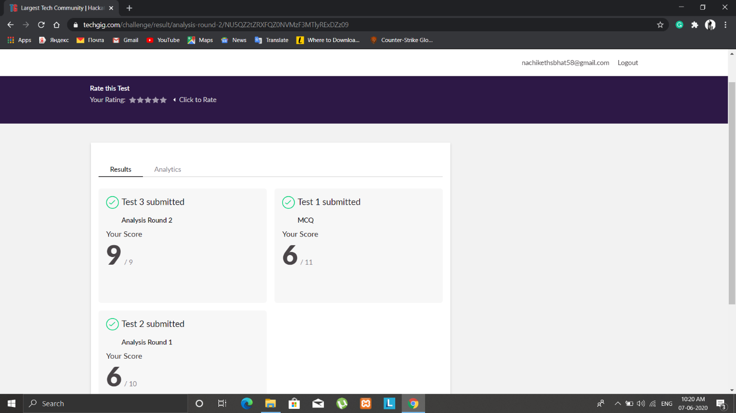

**Certification Course Details:**

**E-Box Classes:**

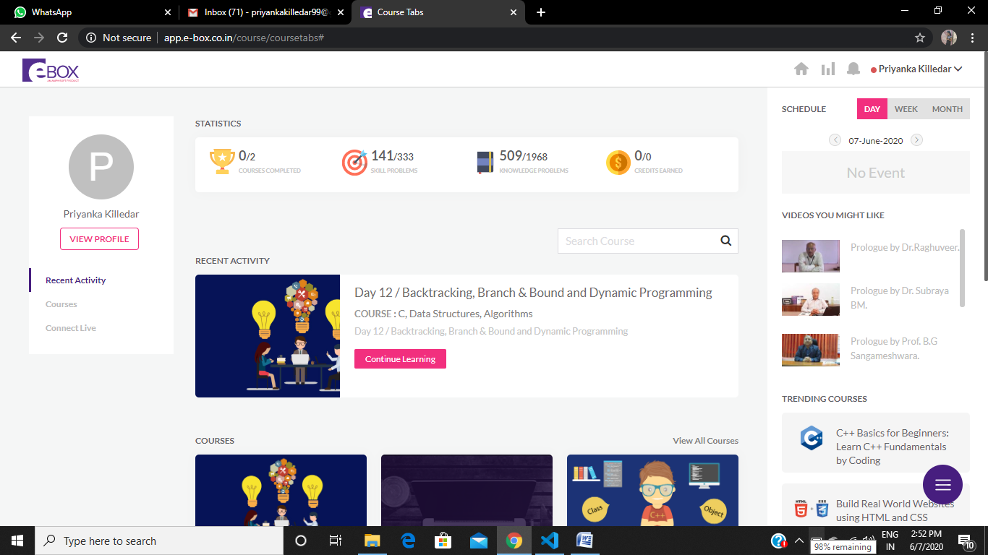

ONLINE PROGRAMING

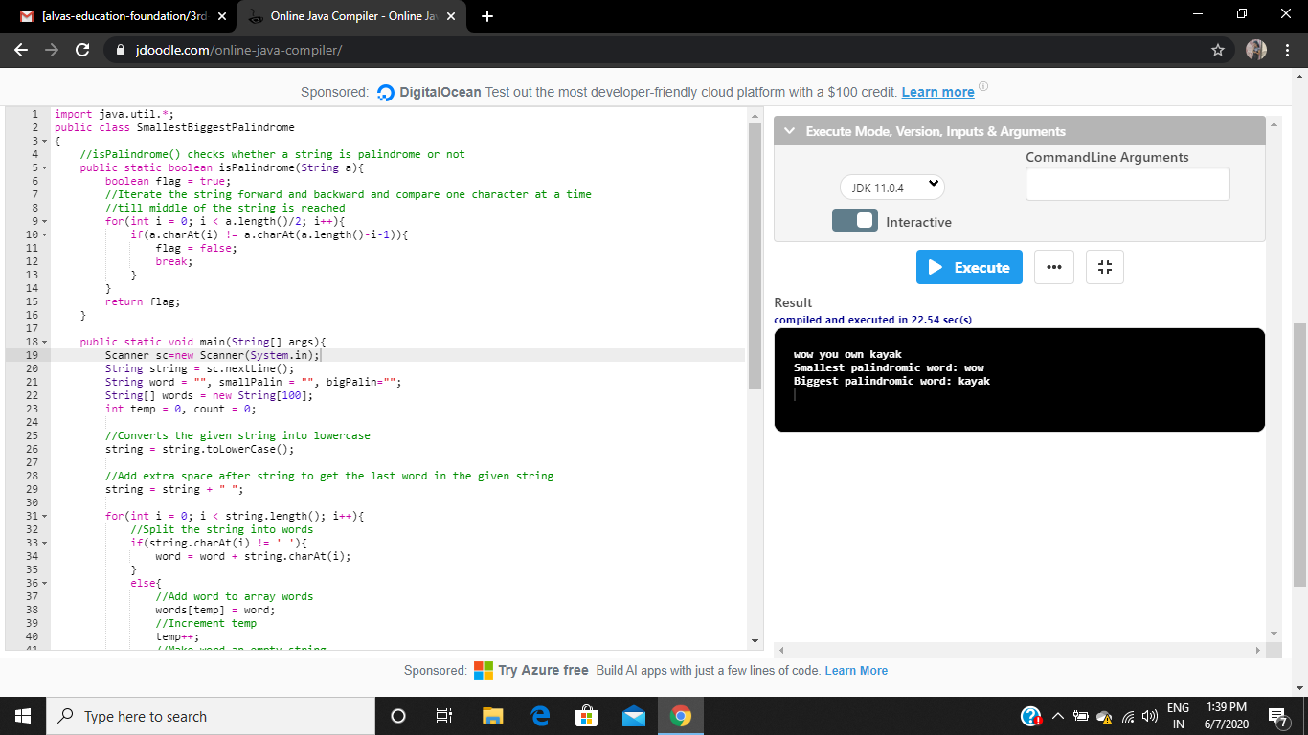P-1 P-2

